Supplementary Guidelines (Learning Outcomes and Assessment)

A support resource for staff constructing course outlines documents

Contents

Constructive Alignment 2
Learning outcomes 4
Verbs in learning outcomes 4
Key points in writing learning outcomes 5
Example of a learning outcome 6
Types of knowledge 6
Blooms Taxonomy 7
SOLO Taxonomy Descriptions 8
SOLO Taxonomy Figure 8
SOLO Taxonomy Nomenclature 9
Video clip about SOLO Taxonomy 9
Marzano and Kendall: The New Taxonomy Education Objectives 10
What activities are teaching methods most likely to elicit? 11
Required levels and kinds of understanding and suitable assessment 12
Comparison of assessment methods 13
Suitable tasks according to generic domains of learning outcomes 17
References 22

Constructive Alignment

Constructive alignment within course and curriculum is essential in meeting high quality learning outcomes for our students.
A simplistic view of contructive alignment
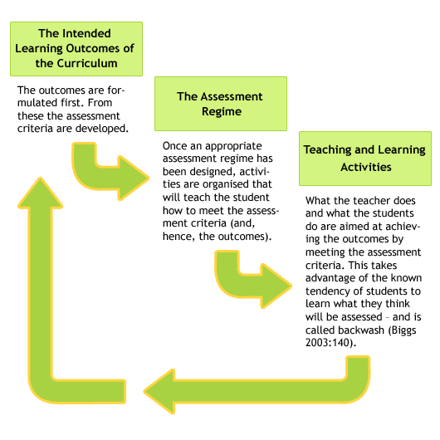
Accessed from: http://www.ucdoer.ie/images/3/3c/Aligned-curriculum-model.gif
A complex view of contructive alignment
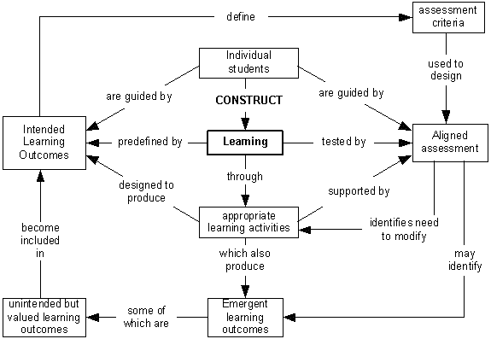
Accessed from: http://exchange.ac.uk/images/learning-teaching-guide/Image2.gif

Learning Outcomes

Learning outcomes are an essential part of any course outline because they set out what students should know and be able to do at the completion of the course.
Effective learning outcomes (or objectives) are important for staff because they:
- direct what ‘content’ (knowledge, skills application of knowledge and skills) should be taught and what students should learn
- determine what teaching strategies and learning experiences are needed to help students learn
- direct what needs to be assessed
- are used to develop criteria for assessment tasks to judge what students know and can do as a result of their learning
- contextualise selected University generic FEDTASKs for the discipline and year level of the course
- inform evaluation of the course

Effective learning outcomes are important for students because they provide them with a:
- framework to guide and focus their studies
- discipline-specific set of statements that articulate with FEDTASKs and/or discipline standards at course and/or university level (UoW 2004).

Verbs in Learning Outcomes

A well-constructed learning outcome requires a verb. There are several taxonomy frameworks which assist in classifying learning outcomes, i.e. from simple to complex and from concrete to abstract. All taxonomies have their limitations however they are helpful in exploring levels of understanding. Three frameworks are described in these guidelines:
- Revised Bloom’s Taxonomy (2001). (Original Blooms Taxonomy was developed in 1956) and
- John Biggs (1999). SOLO (Structure of Observed Learning Outcome) Taxonomy.
- Robert Marzano (2007): A New Taxonomy of Educational Objectives.

Key Points in Writing Learning Outcomes

When you write learning outcomes, ensure that they are focussed on what the learner should be able to know and do at the end of this course and are therefore achievement-oriented.
- Identify important learning requirements that are about ‘knowing’ and ‘doing’, i.e. the range and type of knowledge, skills and application of knowledge and skills. This means not focusing on the fine details such as ‘state the formula for…’, ‘list the causes of…’. These sorts of details are for learning experiences or in specific assessment tasks, not in learning outcomes.
- Learning outcomes should be broad enough to provide enough detail on how the intentions (or goals) of the course will be realised but not so broad that they end up as goals for the course. For example, outcomes that use words such as ‘become aware of’, ‘appreciate’’, ‘learn about’, ‘understand’, ‘become familiar with’, ‘develop the ability to’, are the essence of goals (the ‘big picture’). They are too broad for learning outcomes and are hard to assess validly. These goals need to be turned into actions. In contrast, if you write outcomes that are too specific, they will restrict what you can teach and assess from year to year.
- To write learning outcomes as action statements, begin with an action verb, e.g. ‘demonstrate’, apply’, ‘devise’, ‘reflect’. Then you add other components such as nouns, adjectives, adverbs, phrases, clauses, etc to reflect knowledge and contexts.
- Keep to one discrete, but broad learning outcome per statement.
- Ensure that each outcome is achievable and assessable. This means it is therefore suitable for the particular year level of the course and the discipline.
- Learning outcome statements need to align with valid assessment tasks which provide evidence of learning. Learning outcomes should also consider the institutions student FEDTASKs to ensure all courses contribute to some if not all attributes.
- Learning and teaching activities should also reflect strategies to assist students in meeting the desired learning outcome.
- When you have finished developing the outcomes, check that they reflect the initial intent. Ensure the learning outcomes are the same in the official course outline and the official course description documents. Finally ensure that the assessment tasks and the evidence collected from that task align (UTAS 2011).

Example of a Learning Outcome
(UTAS 2011)
adjective that refers to the context of the situations
from ‘that’ to the end of the sentence is a clause that highlights the purpose of the hypotheses
verb
verb

Analyse and interpret clinical situations to propose hypotheses that determine the strategy for data gathering

phrase refers to purpose of the strategy
noun
verb
noun
verb
noun

Types of Knowledge
For ideas about types of knowledge, you could consider the different ways these two authors have grouped knowledge:
(i) Biggs (1999) (pg 41)
- Declarative — knowing what, or knowing about
- Procedural — knowing how to do things
- Conditional — knowing when to do things
- Functioning —knowing how to employ the first three types of knowledge to solve problems and function as an effective professional.
(ii) Anderson & Krathwohl (2001)
- Factual— basic to specific disciplines such as essential facts, terminology, details or elements.
- Conceptual — discipline-specific such as classifications, principles, generalizations, theories, models, or structures
- Procedural — discipline-specific such as methods of inquiry, very specific or finite skills, algorithms, techniques, particular methodologies
- Metacognitive — knowledge of one’s own cognitive processes (self-knowledge) including reflective knowledge of how to go about solving problems.

Blooms Taxonomy
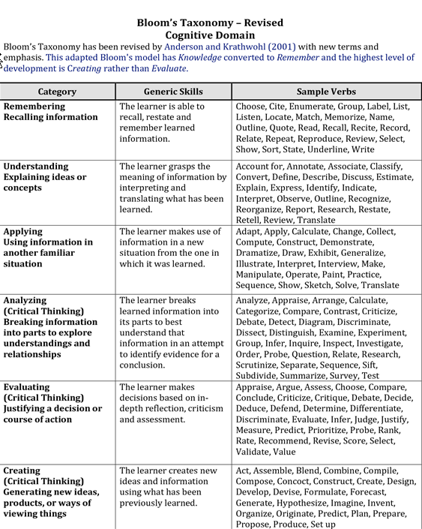
(Anderson & Krathwohl (2001). Blooms (1956)

SOLO Taxonomy Descriptions
(Biggs, 1999)

SOLO Taxonomy Figure
(Biggs & Tang, 2007, page 79) 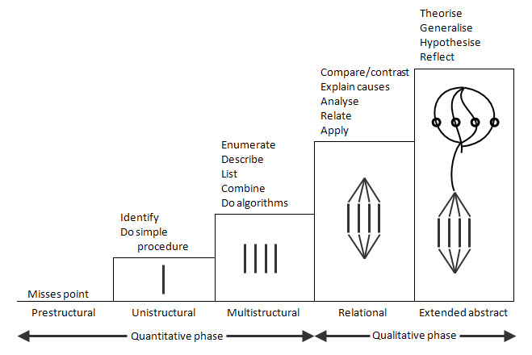

SOLO Taxonomy Nomenclature

Level of Understanding: Pre-structural
No understanding demonstrated and approach involves acquiring disconnected bits of information. Student misses the point.
Level of Understanding: Uni-structural
Student shows concrete, reductive understanding of the topic. Simple and obvious connections are made but broader significance is not understood.
Indicative verbs: identify, memorise, do simple procedure
Level of Understanding: Multi-structural
Student can understand several components but the understanding of each remains discreet. A number of connections are made but the significance of the whole is not determined. Ideas and concepts around an issue are disorganised and aren't related together
Indicative verbs: enumerate, classify, describe, list, combine, do algorithms
Level of Understanding: Relational
Student can indicate connection between facts and theory, action and purpose. Shows understanding of several components which are integrated conceptually showing understanding of how the parts contribute to the whole. Can apply the concept to familiar problems or work situations.
Indicative verbs: compare/contrast, explain causes, integrate, analyse, relate, apply
Level of Understanding: Extended Abstract
Student conceptualises at a level extending beyond what has been dealt with in the actual teaching. Understanding is transferable and generalizable to different areas.
Indicative verbs: theorise, generalise, hypothesise, reflect, generate
(Biggs, 1999).

Video Clip about SOLO Taxonomy

This is simple way to look at SOLO Taxonomy in a 5min YouTube SOLO clip. Accessed from: http://www.youtube.com/watch?v=uDXXV-mCLPg

Marzano & Kendall: The New Taxonomy Education Objectives

Self-System
Beliefs About the  Importance of Knowledge |  | Beliefs about Efficacy |  | Emotions Associated with  Knowledge
Metacognitive System
Specifying  Learning Goals | Monitoring the  Execution of  Knowledge |  | Monitoring Clarity |  | Monitoring Accuracy
Cognitive System
Knowledge  Retrieval | Comprehension |  | Analysis |  | Knowledge  Utilization
Recall  Execution | Synthesis  Representation |  | Matching  Classifying  Error Analysis  Generalizing  Specifying |  | Decision Making  Problem Solving  Experimental Inquiry  Investigation
Knowledge Domain
Information |  | Mental Procedures |  | Physical Procedures

(Marzano & Kendall, 2007)

What Activities are Teaching Methods Most Likely to Elicit?

Each teaching/learning activity | A form of learning
Teacher-controlled  Lecture, set texts  Think-aloud  Questioning  Advance organiser  Concept mapping  Tutorial  Laboratory  Excursion  Seminar  Peer-controlled  Various groups  Learning partners  Peer teaching  Spontaneous collaboration  Self-controlled  Generic study skills  Content study skills  Metacognitive learning skills | Reception of selected content  Demonstrator conceptual skills  Clarifying, seeking error  Structuring, preview  Structuring, overview  Elaboration, clarification  Procedures, application  Experiential knowledge, interest  Clarify, presentation skill  Elaboration , problem-solving, metacognition  Resolve differences, application  Depends whether teacher or taught  Breadth, self-insight  Basic self-management  Information handling  Independence and self-monitoring

(Biggs 1999, pg 118)

Required Levels and Kinds of Understanding and Suitable Assessment

Objectives | Kinds and levels of understanding | Suitable assessment
- Basic facts, terminology  - Topic knowledge  - Discipline knowledge  - Functioning knowledge  - Laboratory skills  - Monitoring and evaluation skills | Recall, recognition  Individual topics, relational, some multi-structural relations between topics  Conception of course as a whole  Topic or discipline  Procedural knowledge  Metacognitive knowledge, self-directed learning | Multiple choice or short answer  Gobblets (fill in the gaps), critical incidents  Letter to a friend, concept map  Problem-solving, research project  Laboratory behaviour, lab reports  Self and peer assessment

(Biggs 1999, pg 196)

Comparison of Assessment Methods

Assessment Method | Some Possible Learning Outcomes | Some Possible Advantages | Some Possible Disadvantages/ Issues
Assignment - essay | Research and synthesise information; make an argument; interpret and evaluate ideas. | Relatively easy to set. Appropriate for testing higher order thinking. | Reduced reliability with different markers. May be time consuming to mark.
Assignment – problem centred or case study | Problem solving; application and interpretation of knowledge; synthesise and evaluate. | More realistic test of ability, e.g. closer to performances required in professional practice. | Cases / problems must be well designed to include appropriate level of complexity and generate genuine inquiry.
Assignment – short answer questions | Knowledge and understanding. | Reasonably easy to set. Allows broad coverage of syllabus. Consistency in marking. | Little opportunity to make an argument or display original thinking.
Projects and theses | Identify, define and solve problems; research and synthesise information; structure and present an argument. Read widely, interrelate, organize, apply and copy | Allows students to pursue individual interests – can be highly motivating. Allows for creative and original work. | May require unforseen amounts of work on the student’s part. Time consuming to mark. Reliability in marking difficult to achieve.
Exam - essay | Remember, organise and structure information; structure and present an argument under pressure. Rote, question spotting, speed structuring | Relatively easy to set. Allows confidence about authorship | Different questions often require different levels of ability (eg. describe v. criticise). Comparisons of student performance therefore difficult.
Exam - Open book | Problem solving; application & interpretation of knowledge; use reference materials effectively. Rote, question spotting, speed structuring. Coverage | Less study time spent on memorising; thought required in studying for the exam and in writing the response. | Questions should be set so that they require real thinking and not just looking up the answer.

Assessment Method | Some Possible Learning Outcomes | Some Possible Advantages | Some Possible Disadvantages/ Issues
Exam - Oral / vivas | Oral communication skills; reasoning behind judgement and actions. | May be used to confirm practical / clinical assessments. | May be subjective. Personal factors may influence assessor. Variability in questions asked may mean students face different tests. May be highly stressful for some students.
Exam - Problem centred or case study | Problem solving; application and interpretation of knowledge; synthesise and evaluate material. | More realistic test of ability, e.g. closer to performances required in professional practice. | Cases / problems must be well designed to include appropriate level of complexity and generate genuine inquiry.
Exam - Short answer questions | Knowledge and understanding. | Reasonably easy to set. Allows broad coverage of syllabus. Consistency in marking. | Little opportunity to make an argument; display original thinking.
Exam - MCQ, true / false etc | Knowledge and understanding; interpret data; Recognition strategy, comprehension, coverage | Broad coverage of syllabus possible. Reliable marking. | Difficult and time consuming to set. Cannot test ability to make an argument, defend judgment, display original thinking.
In-session Tests/Quizzes | Knowledge and understanding; Interpret data; diagnosis. | Useful means of assessing progress. Can provide an early warning sign for students who are experiencing difficulties. Can be used as Pre-test: help prepare students for final exams. | Can be difficult to supervise in large lecture theatre.  Little opportunity to make an argument; display original thinking.
Laboratory exercises / reports | Practical skills. Safety requirements. Follow procedures accurately. Understanding of scientific method. Document experiments.  Skills needed in real life | A learning experience as well as an assessment task – learning by doing. | Written report rather than practical skills usually assessed.

Assessment Method | Some Possible Learning Outcomes | Some Possible Advantages | Some Possible Disadvantages/ Issues
Journals, diaries and log books | Reflection on practice. Growth in understanding. Reasoning behind judgements and actions. Attitudes, reflection application, sense of relevance | Requires deep thinking about practical exercises and field placements. May help to integrate theory and practice. | Often an unfamiliar assessment tool that students may resist. Difficult to assess attitudes.
Seminar presentation | Oral presentation skills. Lead a discussion. Research, organise information and make an argument. Communication skills | May simulate presentations required in professional practice. | Guidance on effective presentation and group facilitation skills required. Variability in audience may make comparisons difficult.
Performance (music, dance, theatre, etc) | Interpret an artistic work. Creativity. Technical skill. | Multiple assessors improve reliability of a highly subjective assessment event.  Assessment by panel will improve reliability | Panel assessment can be highly stressful for students. Criteria for successful performance need to be clearly written.
Creative work (exhibitions, portfolios, websites etc) | Creativity and originality. Technical skill. Application of knowledge. Reflection, unintended outcomes | Allows students to pursue individual interests – can be highly motivating. Allows for creative and original work.  Assessment by panel will improve reliability | May require unforseen amounts of work on the student’s part. Time consuming to mark. Reliability in marking difficult to achieve.
Simulated professional tasks | Technical skill. Interpersonal skills. Problem solving ability. Application of knowledge.  Attitudes. Application and professional skills | Closely approximates professional work | Preparation of markers’ checklists and training of assessors may be necessary to ensure reliability. May be time consuming and expensive to assess. Reliability in marking difficult to achieve.

Assessment Method | Some Possible Learning Outcomes | Some Possible Advantages | Some Possible Disadvantages/ Issues
Design tasks | Problem solving ability. Creativity. Technical skills. Presentation skills. | Allows students to pursue individual interests – can be highly motivating. Allows for creative and original work.  Assessment by panel will improve reliability.  Displays or presentations of design solutions help make standards clear to students. | Difficult to make reliable assessments of widely differing design solutions – clearly written and weighted criteria will help
Class participation | Preparation, oral communication skills, comprehension, involvement and enthusiasm. | May improve attendance and preparation. Offers opportunity to assess students’ engagement with, and ability to debate, ideas. | Criteria for successful performance need to be clearly written. Assessment may be highly subjective and unreliable. Provision for equal opportunity for participation is required.
Rapid Assessment (large class) | Concept map  Venn Diagrams  Three-minute essay  Gobbets  Short Answer  Letter to a friend | Coverage, relationships  Relationships  Level of understanding, sense of relevance  Realizing the importance of significant detail  Recall courses of information, coverage  Holistic understanding, application, reflection

Adapted from Jaques (1989) and Biggs (1999, pg 200)

Suitable Tasks According to Generic Domains of Learning Outcomes

Generic domains of learning | Suitable tasks or methods to engender learning in these domains
Thinking critically and making  judgments  (Developing arguments, reflecting,  evaluating, assessing, judging) | 1. Essay  2. Report  3. Journal  4. Letter of advice to...  5. Present a case for an interest group  6. Prepare a committee briefing paper for a specific meeting  7. Book review (or article) for a particular journal  8. Write a newspaper article for a foreign newspaper  9. Comment on an article's theoretical perspective
Solving problems and  developing plans  (Identifying problems, posing  problems, defining problems,  analysing data, reviewing,  designing experiments, planning,  applying information) | 1. Problem scenario  2. Group work  3. Work-based problem  4. Prepare a committee of enquiry report  5. Draft a research bid to a realistic brief  6. Analyse a case  7. Conference paper (or notes for a conference paper plus annotated bibliography)
Performing procedures and  demonstrating techniques  (Computation, taking readings,  using equipment, following  laboratory procedures, following  protocols, carrying out instructions | 1. Demonstration  2. Role play  3. Make a video (write script and produce/make a video)  4. Produce a poster  5. Lab report  6. Prepare an illustrated manual on using the equipment, for a particular audience  7. Observation of real or simulated professional practice

Generic domains of learning | Suitable tasks or methods to engender learning in these domains
Managing and developing  oneself  (Working co-operatively, working  independently, learning  independently, being self-directed,  managing time, managing tasks,  organising) | 1. Journal  2. Portfolio  3. Learning contract  4. Group work
Accessing and managing  information  (Researching, investigating,  interpreting, organising  information, reviewing and  paraphrasing information,  collecting data, searching and  managing information sources,  observing and interpreting) | 1. Annotated bibliography  2. Project  3. Dissertation  4. Applied task  5. Applied problem
Demonstrating knowledge and  understanding  (Recalling, describing, reporting,  recounting, recognising,  identifying, relating and  interrelating) | 1.Written examination  2. Oral examination  3. Essay  4. Report  5. Comment on the accuracy of a set of records  6. Devise an encyclopaedia entry  7. Produce an A–Z of ...  8. Write an answer to a client's question  9. Short answer questions: True/False/ Multiple Choice Questions (paper-based or  computer-aided assessment)

Generic domains of learning | Suitable tasks or methods to engender learning in these domains
Designing, creating, performing  (Imagining, visualising, designing,  producing, creating, innovating,  performing) | 1. Portfolio  2. Performance  3. Presentation  4. Hypothetical  5. Projects
Communicating  (One and two-way  communication, communication  within a group, verbal, written and  non-verbal communication.  Arguing, describing, advocating,  interviewing, negotiating,  presenting, using specific written  forms) | 1. Written presentation (essay, report, reflective paper, etc.)  2. Oral presentation  3. Group work  4. Discussion/debate/role play  5. Participate in a "Court of Enquiry"  6. Presentation to camera  7. Observation of real or simulated professional practice

(Nightingale et al. 1996).
NB: This resource include exemplars for each domain of learning and it is a great resource

Assessment Futures 2020: 7 Principles of Assessment in Higher Education

This document is an assessment guideline reform which provides key principle regarding effective assessment. It should be helpful when reflecting on assessment practices.
- Assessment is used to engage students in learning that is productive.
- assessment is designed to focus students on learning.
- assessment is recognised as a learning activity that requires engagement on appropriate tasks.

- Feedback is used to actively improve student learning
- feedback is informative and supportive and facilitates a positive attitude to future learning.
- students seek and use timely feedback to improve the quality of their learning and work.

- Students and teachers become responsible partners in learning and assessment.
- students progressively take responsibility for assessment and feedback processes.
- students develop and demonstrate the ability to judge the quality of their own work and the work of others against agreed standards.
- dialogue and interaction about assessment processes and standards are commonplace between and among staff and students.

- Students are inducted into the assessment practices and cultures of higher education.
- assessment practices are carefully structured in early stages of courses to ensure students make a successful transition to university study in their chosen field.
- assessment practices respond to the diverse expectations and experiences of entering students.

- Assessment for learning is placed at the centre of subject and program design.
- assessment design is recognised as an integral part of curriculum planning from the earliest stages of course development.
- assessment is organized holistically across subjects and programs with complementary integrated tasks.

- assessment for learning is a focus for staff and institutional development.
- professional and scholarly approaches to assessment by academic staff are developed, deployed, recognised and rewarded by institutions.
- assessment practices and the curriculum should be reviewed in the light of graduate and employer perceptions of the preparedness of graduates.
- assessment of student achievements is judged against consistent national and international standards that are subject to continuing dialogue, review and justification within disciplinary and professional communities.

- assessment provides inclusive and trustworthy representation of student achievement
- interim assessment results used for feedback on learning and progress do not play a significant role in determining students’ final grades.
- evidence of overall achievement to determine final grades is based on assessment of integrated learning.
- certification accurately and richly portrays graduates’ and students’ achievements to inform future careers and learning.

Access from: http://www.uts.edu.au/research-and-teaching/teaching-and-learning/assessment-futures/overview.

References
Anderson, L. (Ed.), Krathwohl, D. (Ed.), Airasian, P., Cruikshank, K., Mayer, R., Pintrich, P., Raths, J., & Wittrock, M. (2001). A taxonomy for learning, teaching, and assessing: A revision of Bloom's Taxonomy of Educational Objectives (Complete edition). New York: Longman.
Biggs, J. & Tang, C. (2007). Teaching for Quality Learning at University. Accessed from http://glasgowtweacher.wordpress.com/
Biggs, J. (1999). Teaching for Quality Learning at University. Open University Press.
Bloom, B., Englehart, M. Furst, E., Hill, W., & Krathwohl, D. (1956). Taxonomy of educational objectives: The classification of educational goals. Handbook I: Cognitive domain. New York, Toronto: Longmans, Green.
Jaques, D. (1989). In: Module 10 Course Design Certificate in Teaching and Learning in Higher Education course materials. 1989. Oxford Centre for Staff Development. Resource within University of Wollongong (UoW): Good Practice Assessment 2004. Accessed from: http://www.uow.edu.au/about/policy/UOW058614.html#P175_7612
Marzano, R.J. and J.S. Kendall, eds. The New Taxonomy of Educational Objectives. 2nd ed. 2007, Corwin Press: Thousand Oaks, California. Accessed from: http://thekglawyerblog.com/ptblog/articles/from-bloom-to-marzano-a-new-taxonomy-of-educational-objectives-for-plt/
Nightingale, P., Wiata, I., Toohey, S., Ryan, G., Hughes, C. and Magin, D. (1996). Assessing Learning in Universities. Kensington: UNSW Press. Accessed from: http://www.medev.heacademy.ac.uk/assets/documents/resources/database/id235_assessing_learning_in_universities.pdf
University of Tasmania (UTAS) (2011). Good Assessment Practice. Accessed from: http://www.teaching-learning.utas.edu.au/__data/assets/pdf_file/0004/158674/GAG_v16_webversion.pdf
University of Wollongong (UoW) 2004. Good Practice Assessment 2004. Accessed from: http://www.uow.edu.au/about/policy/UOW058614.html#P175_7612

